WILL CLIMATE CHANGE AFFECT WHAT’S ON OUR PLATES?
By LUNA HUSSein DATE AUGUST 2019
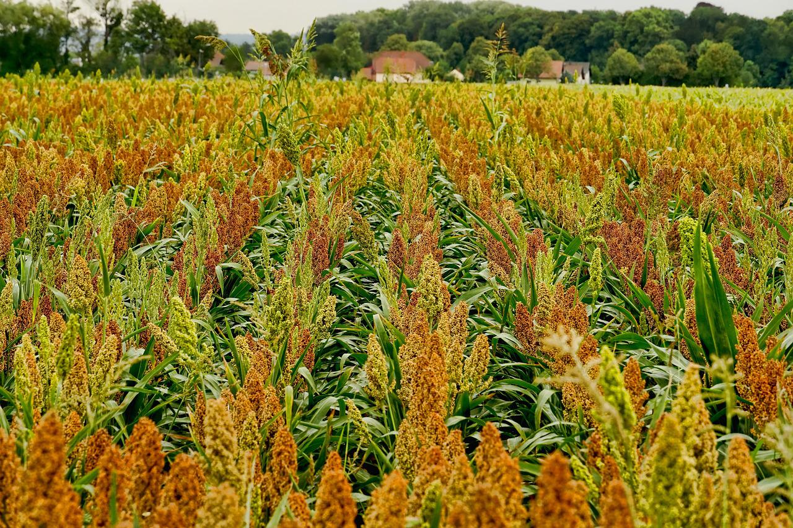
Climate change is affecting the growth of traditional grains such as wheat, meaning that people might need to get used to different grains, such as sorghum (above).
Image from pixabay

Wheat farmers in France in 2016 were surprised with a much smaller harvest than they were used to. Crop yields can vary year on year, but generally fall within 5% above or below normal levels. But in 2016, some farmers found that their wheat yield was only 50% of its normal size. So what happened?
There was not one obvious answer, but rather several smaller factors that had combined to cause the problem. The winter of 2015-16 had been warmer than usual and was combined with a long period of heavy rainfall. When heavy rains fall on farmland, often nutrients are leached out of the soil and into rivers and lakes, reducing the amount of nutrients available for growing crops.
This combination of hot and wet weather also proved to be perfect for spreading diseases. When crops are grown close together, it is very easy for harmful microorganisms to spread between them, restricting the growth of crops and sometimes even destroying them altogether.
None of these conditions (unexpected warmth, heavy rains and disease) would have been catastrophic alone, but the combination of them together was disastrous for the wheat farmers in France.
Luckily, France is an economically wealthy country and was able to import wheat and other grains from different countries, so the problem was not felt by most French citizens. Climate scientists warn, however, that if these problems start to occur more regularly in developing countries, the consequences could be much more severe, worsening poverty and in extreme cases bringing on a famine.
Changes in weather patterns as a result of global warming could mean that farmers are not able to grow the quantity or type of crops that we are used to. They may have to move to farming more resilient grains, such as sorghum, that are less vulnerable to drought.
When people think of the consequences of global warming, most people think of severe weather events, flooding and wildfires, as well as habitat and biodiversity loss. The threat posed by global warming to farming, however, should not be underestimated. Scientists are continuing to investigate ways of growing crops to help protect food security across the world.

Answer the following questions in full sentences:
- What is this news story about?
___________________________________________________________________________________________
___________________________________________________________________________________________
___________________________________________________________________________________________

- What were the causes of this poor harvest?
___________________________________________________________________________________________
___________________________________________________________________________________________
___________________________________________________________________________________________
___________________________________________________________________________________________
___________________________________________________________________________________________

- Why did this poor harvest not affect many French people?
___________________________________________________________________________________________
___________________________________________________________________________________________
___________________________________________________________________________________________
- What effect could a poor harvest have on a less wealthy country?
___________________________________________________________________________________________
___________________________________________________________________________________________
___________________________________________________________________________________________
- How will climate change how farmers work?
___________________________________________________________________________________________
___________________________________________________________________________________________
___________________________________________________________________________________________

- Write down the meanings of any words in bold in the article.
___________________________________________________________________________________________
___________________________________________________________________________________________
___________________________________________________________________________________________
___________________________________________________________________________________________
___________________________________________________________________________________________
___________________________________________________________________________________________

